1. Write a program to accepts two numbers from stdin and find all the odd as well as even numbers present in between them.

import java.util.Scanner;

public class Main {

private static Scanner sc;

public static void main(String[] args) {

// TODO Auto-generated method stub

sc = new Scanner(System.in);

int a=sc.nextInt(); // gets start range

int b=sc.nextInt();//gets the stop range

System.out.println("EVEN\n");

for(int i=a;i<=b;i++)

{

if(i%2==0){

System.out.println(i); // prints even nos.

}}

System.out.println("ODD");

for(int i=a;i<=b;i++)

{

if(i%2!=0){

{

System.out.println(i);//prints odd nos.

}}

}}}

OUTPUT:

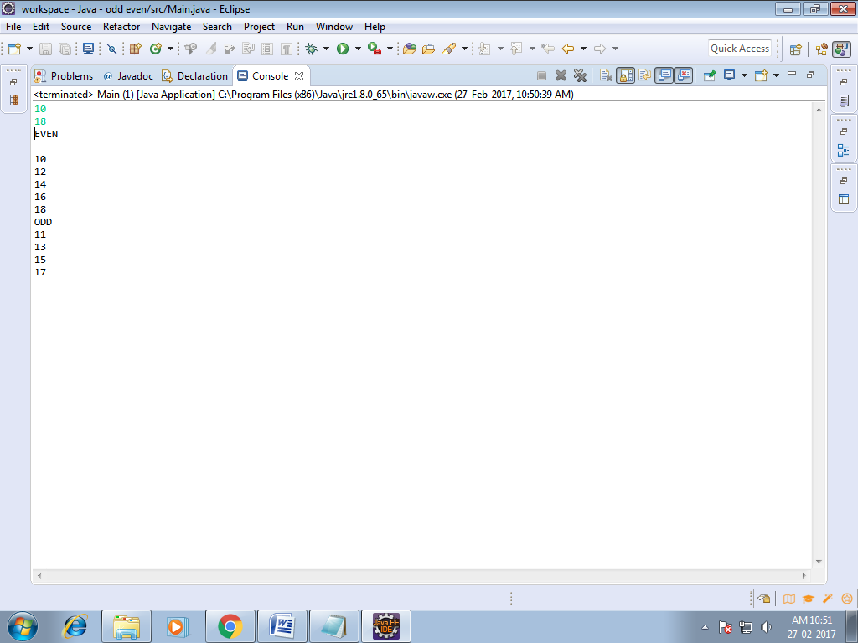

1. Joe is scared to go to school. When her dad asked the reason, joe said she is unable to complete the task given by her teacher. The task was to find the “first 10 multiples” of the number entered from stdin

import java.util.Scanner;

public class Main {

private static Scanner sc;

public static void main(String[] args) {

// TODO Auto-generated method stub

sc = new Scanner(System.in);

int a=sc.nextInt();//gets the no. From stdin

for(int i=1;i<=10;i++)

System.out.println(a+" \* "+i+" = "+a\*i);

// computes and prints the first 10 multiples of the entered no.

}

}

OUTPUT:

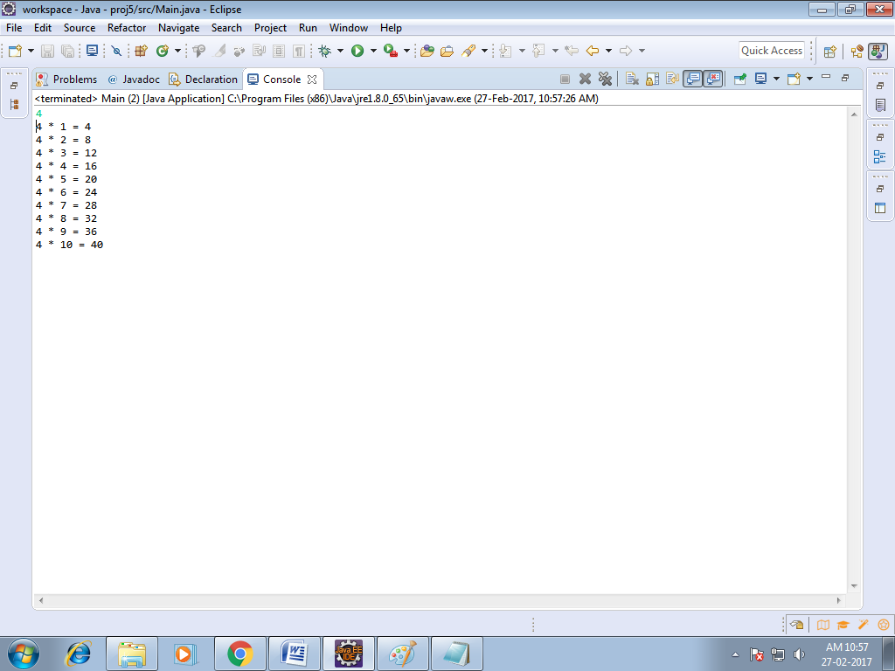

3) Write a program consisting method sum() and demonstrate the concept of method overloading using this method.

public class Main {

public static void main(String[] args) {

// TODO Auto-generated method stub

System.out.println(sum(2,3));//invokes the sum() with 2 arguments

System.out.println(sum(20,30,40));// invokes the sum() with 3 arguments

}

static int sum(int a,int b)// sum() defined with 2 arguments

{

int z;

z=a+b;

System.out.println(“Sum is : ”);

return z;

}

static int sum(int a,int b,int c)// sum() overloaded with 3 arguments

{

int z;

z=a+b+c;

System.out.println(“Sum is : ”);

return z;

}

}

OUTPUT:

